Content Requirements:

Script/Copy:

* Main message or slogan.
* Key information and descriptions. Logo:

~High-resolution logo files. Images:

* Relevant high-quality images. Contact Information:
* Address, phone number, email. Testimonials:
* Quotes from supporters or beneficiaries. Partners:
* Logos and names of partner organizations. Website Goals:
* What you want to show (e.g., mission, projects, how to donate).

# Content Development Script/Copy

About Us

Welcome to VCNC (Vulnerable Children Need Care), a beacon of hope and support for vulnerable children. Founded in 2019 in the heart of Kigali, Kimironko, Kwa Mushimire center, VCNC was born out of a deep compassion and commitment to transforming the lives of children in need.

Our journey began with our founder's simple yet profound gesture of connecting with street children through the universal language of music. Playing guitar for emotional healing, visiting the families of those who had them, and listening to their stories, our founder laid the foundation for what would become a thriving community dedicated to the well-being of vulnerable children. During the COVID-19 pandemic, the need to help these street children intensified even further. More children were exposed to poverty, more families fell unable to cater for their offsprings, which all contributed to an increase of street children and school dropouts.

The founder reached out to like-minded youths to organize a christmas day which took place on December 26, 2024, where 34 street children were hosted.

This marked the birth of VCNC. The attendees were inspired by the dreams the kids had, and the desire to transform their lives. It was immediately concluded to take the most promising kids back to school, encourage them to go back to their families, and provide basic needs they faced

regularly.

# Mission

VCNC is dedicated to providing holistic support to young, vulnerable children facing adversity. Our mission is to empower these children by addressing challenges such as addiction to drugs (those already on street), limited access to education, and insufficient basic needs through creative initiatives, community engagement, and collaborative fundraising efforts. We strive to create a positive impact on their lives."

Vision

VCNC envisions a future where every vulnerable child not only overcomes adversity but thrives. Our vision is to build a society that prioritizes the well-being and education of these children, providing them with the support and opportunities needed for a brighter and more promising future.

Values

* + **Visionary Impact (V):** We envision sustainable solutions that address the root causes of challenges faced by our community. We don’t just look for present well being but also equip the community to fight against future adversity. We confirm our existence by seeing the envisioned impact happen through:
    - **Preparedness:** Having the willingness to impact those vulnerable children’s life currently and for the future.
    - **Prevention:** Helping children eradicate the possibility of entering into more adversities like drug addiction, etc.
    - **Mitigation:** facilitate them to survive in such adversities by providing some basic needs.
    - **Retrofitting:** equip vulnerable kids with the right mindset and skills to avoid facing the same challenges they grow up in for their own future families.
* **Compassion (C)** : Every initiative to create a positive difference in the lives of those we serve is valued through empathy, understanding, and commitment. We are today’s good Samaritans because we help without expecting any return. We’re not driven by any relationships other than the shared HUMANITY and don’t expect any financial benefits.
* **Nurturing Collaboration (N)**: we believe that this vision is so much bigger for just an individual so every additional hand towards more impact in people’s lives is encouraged to create a much stronger and supportive community.
* **Community Engagement (C)**: we believe that inclusive participation of each community member will allow us to consider, listen and empower those we serve. There is no perfect solution besides that one thought of with engagement of the impacted.

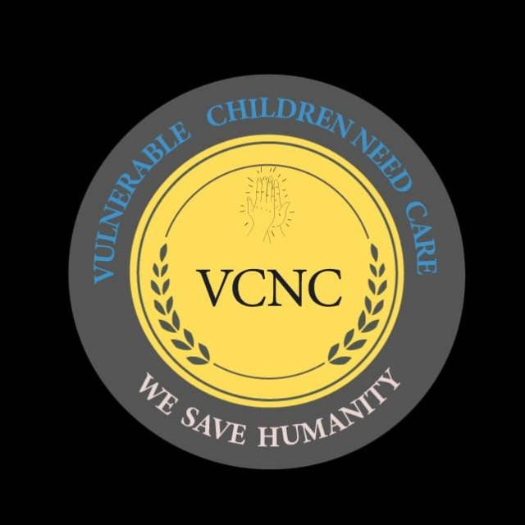Logo

Website Goals:

* What you want to show (e.g., mission, projects, how to donate).

# Project Sustainability:

* + **Goal:** Increase recurring donations by X% within Y timeframe. (This supports ongoing operational costs.)
  + **Goal:** Secure X number of corporate partnerships within Y timeframe. (Partnerships can provide financial and volunteer support.)

# Draw More Impact:

* + **Goal:** Increase the number of children supported by X% within Y timeframe.
  + **Goal:** Launch a new online training hub featuring soft skills, languages, etc., with X number of enrolled users within Y timeframe.
  + **Goal:** Increase participation in after-school support programs by X% within Y timeframe. (Track metrics for specific programs like job hunting or scholarship applications.)

# Raise Funds:

* + **Goal:** Increase online donations by X% within Y timeframe.
  + **Goal:** Launch an online store selling merchandise (t-shirts, hoodies) with a target revenue of Y within Z timeframe.
  + **Goal:** Organize a virtual talent competition or showcase of children's crafts, aiming to raise Z amount within Y timeframe.

# Continuous Growth:

* + **Goal:** Increase website traffic by X% within Y timeframe. (This attracts potential donors, volunteers, and partners.)
  + **Goal:** Conduct a survey to measure website user engagement and satisfaction, aiming for a Z% positive response rate within A timeframe. (Improves user

experience and drives action.)

# Leveraging Resources:

* + **Goal:** Increase volunteer signups by X% within Y timeframe through a dedicated volunteer portal on the website.
  + **Goal:** Launch a member portal to connect with existing members and leverage their skills, connections, and financial capacity. Aim for Z number of member sign ups within A timeframe.
  + **Goal:** Develop a partnership page showcasing existing partnerships and

highlighting benefits for potential corporate partners.